

**Colores**

Bg #002339

Text #fff #333 #019f55

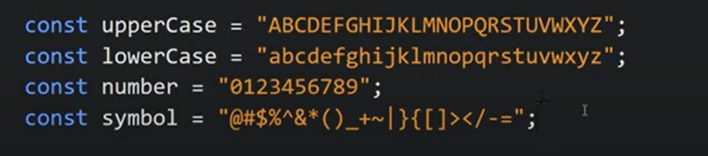

Investigar

